

Project Manager Guide

Created for
Almirall Hermal GmbH

Contents
Overview 3
Common Tempus Shortcuts 4
Tempus Resource Navigation 5
Logging In 5
Homepage 5
How to Subscribe to Notifications 7
Project Management GRId 8
How to Create a Project 8
Creating a project without a template 8
Creating a project with a template 9
View Management 10
How to Update Project Attributes 11
Editing Attributes for a Single Project 11
Editing Attributes for Multiple Projects 11
SINGLE PROJECT ALLOCATION GRID 12
Grid Overview 12
How to Assign Resources to Projects 13
Replacing a Resource 15
Resource Replace Screen 15
Fully or Partially Replacing a Resource 16
Advanced Assignment Options 17
Cloning an Assignment 17
Shifting an Assignment 17
Bulk Project Allocation Flatgrid 18
Grid Overview 18
How to Create a Multi-Project View 20
Actions in the BPA Flatgrid 22
Updating existing assignments 22
Adding new assignments 22
Replacing a Resource (Resource Replace Advanced) 23

Overview

- User Access:
Tempus access will vary based on the setup of each individual user (managed by your Admin team)
Resources who require access can login via SSO and will be assigned a user role and security group

- Resource Types:
There are two types of resources that can be setup in Tempus
  - Named resources: Individuals allocated to projects and/or setup as Tempus users
  - Group resources: Resources with underlying capacity for multiple resources e.g., QP Generic (SAB)
  - Demand Planning resources: Unnamed resources; generic placeholders for a team or role, used solely for planning

- Project Types:
There are three types of projects setup in your Tempus instance
- Standard projects: “Interrelated tasks organized together in order to reach a specific outcome”
- Proposals: Projects still pending approval, denoted by a purple P icon
- Non-Project Activities or Business As Usual projects: Absence, Admin, Run, Change, etc.

- Assignments
Assignments are created by linking a Resource to a Project
    - Assignments must include a specific number of time units (Hours, FTE, etc.)
    - Assignments can be created for one project at a time, or for multiple projects at the same time
    - Assignments can be applied to the Project (generic task) or to individual named tasks

Common Tempus Shortcuts

- Tempus grids support the following Excel-like functionality:
  - Column data can be sorted by clicking the column header
  - Cell data can be copy-pasted via CTRL+C and CTRL+V
  - Cell data can be copied across or down by clicking the bottom-right corner of a cell and dragged along

- Tempus use several icons (across multiple screens) to represent specific functionality:
Trash Can: Delete selected item(s)
Pencil: Edit/View selected item
 Copy/Clone: Copy selected item to clipboard OR Clone selected item
 Lock/Unlock: Indicates whether the selected record is locked by another user
Export To: Standard icons for Excel, CSV, or PDF display when applicable
Filter: Filter results based on specified values
Notification: Listed item may need attention (filters, new requests, etc.)
Listed record is a Demand Planning resource (generic, placeholder)
Listed record is a Proposal

Tempus Resource Navigation
Tempus Resource is an easy to use resource management and workforce capacity planning tool with an intuitive user interface. This section covers the three aspects of navigating Tempus – Logging In, different areas of the Homepage and Main Task Bar, and Subscribing to notifications.

Logging In

- Navigate to Tempus Resource using your web browser (https://almirall.tempus-resource.com/sg/)
Google Chrome is the recommended browser.
- Click on the orange button Continue With Microsoft
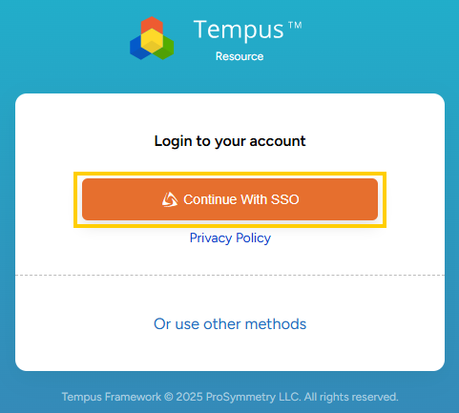
- Sign in using your standard credentials

Homepage

      - All PM users will have access to 6 tiles on their homepage. Click on any tile to navigate to the relevant area.
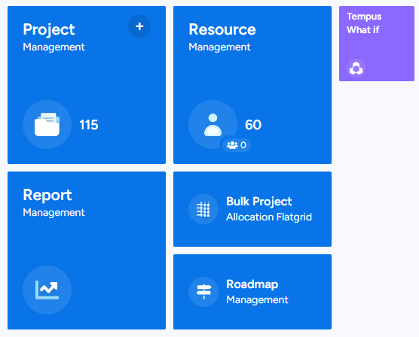

      - The below table provides a high-level description of actions users can perform behind each tile.
Note: The actions may vary depending on each user’s role and access permissions.

Tile name* | Description
Project Management | - View project repository  - Create a new project with/without a template  - View/Create/Edit assignments on individual projects
Bulk Project Allocation Flatgrid | - View/Create/Edit assignments on multiple projects  - View Resource assignments across projects
Resource Management | - View resource repository  - View Resource attributes and Capacity  - View Net Availability Grid for multiple resources
Roadmap Management | View Portfolio roadmap in a Gantt view with resource overallocation risks visualised.
Tempus What-If | Simulate scenarios to analyse impact on resource utilization.
Report Management | View any shared reports and export them in supported formats.
*Areas covered in this guide are highlighted in yellow.
      - The blue ribbon along the top (Task Bar) is available from all screens in Tempus.
- Click on the Tempus logo to the left to return to the homepage from any screen
- View notifications by clicking on the bell icon
- Locate a specific project via Global Search
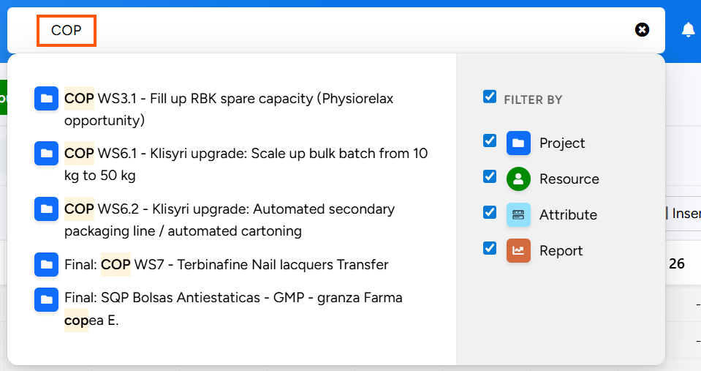
- Navigate to any area of Tempus via the hamburger menu
- From the username menu, set up in-app Subscriptions or Logout.
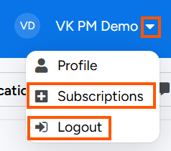

How to Subscribe to Notifications

- From the username menu to the top-right, click on Subscriptions.
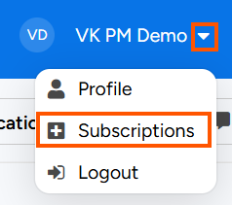
- In the Project tab, click Add projects to choose projects to be notified for. Click the green Add button. NOTE: Do not select all projects as unsubscribing must be done individually.
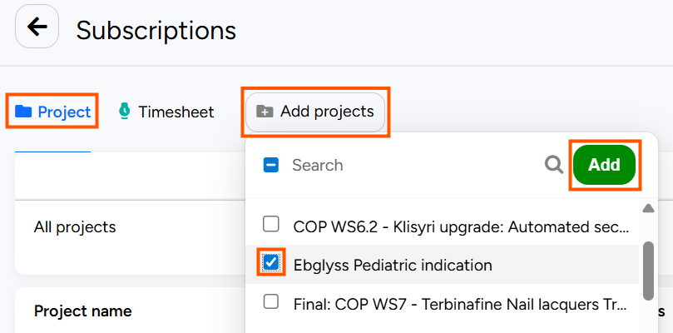
As a default, all notifications will be enabled for selected projects.
- To disable a specific notification,
  - Hover over the cell
  - Click the Edit icon
  - Update Yes to No
  - Click the green Save button.
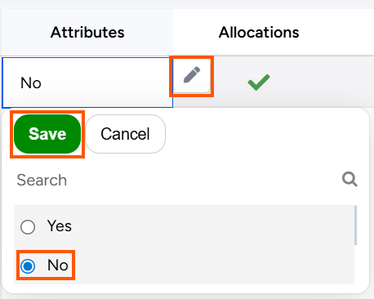
- To update notifications in bulk, follow the same steps as above while selecting multiple cells; by holding down the Shift Key on your keyboard and select multiple cells using arrow keys.
- To unsubscribe from a project, click 

Project Management GRId

Click the Project Management tile to open the Project List, where you have access to the entire project repository.
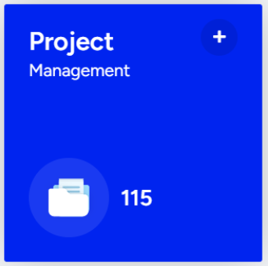

How to Create a Project

Giving users the ability to create new projects and their tasks within the product is a core component of Tempus Resource. This section outlines how to create a project both with and without a template.

Creating a project without a template

- Click on the green Create Project button towards the top-left of your Project Management grid and select Regular Project from the very top of the list.
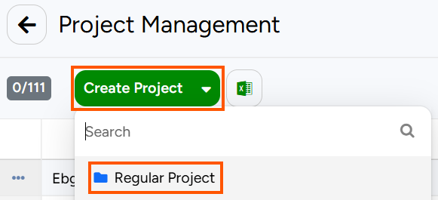
- You will automatically land on the Project Allocations screen, where you can enter a Project Name, Start Date, and End Date
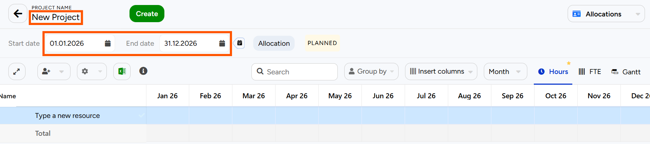
- Click the green Create button to the right of the Project Name to save the new project to your repository.
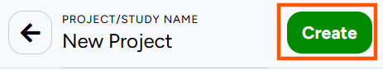

Creating a project with a template
- Click on the green Create Project button towards the top-left of your Project Management grid and select the relevant template from the list.
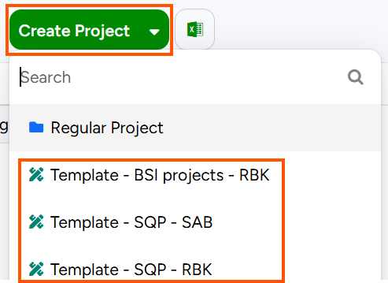
- Clicking the template will open a modal window in the middle of your screen.
Enter the new Project’s name and click Create to save the new project to your repository.
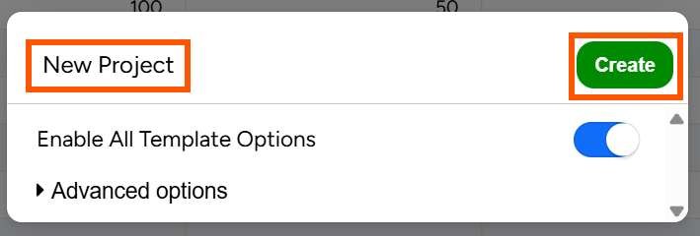
- You will automatically land on the Project Allocations screen. Navigate to Project Attributes from the top-right of the screen.
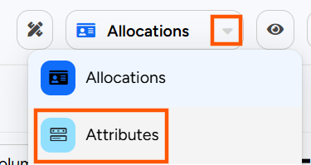
- To update the project timeframe from the template values, click Shift, enter the New start date,
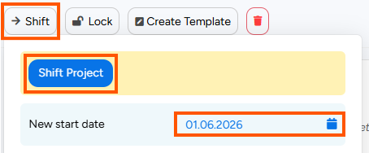
- Review and update all relevant attributes. Ensure that updates are saved by clicking on the green Save button at the very top of the screen.
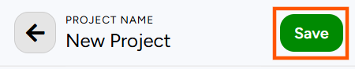

View Management

- Towards the top-right of the grid, there are various options to customise the Project management grid.
    - Use Quick filters to navigate to relevant projects e.g., “my projects” will show projects where the logged in user is assigned as the Project Owner.
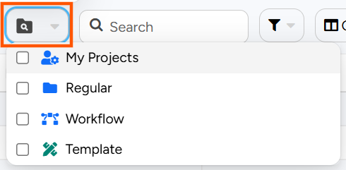
    - Search for a project or projects by name via the search field, which uses “contains” logic.
    - Filter projects by applying as many filters as needed.
    - Add or remove Columns.
    - Group projects based on any attribute(s). Each grouping level will display the group by attribute, attribute value, and the count of projects contained in the grouping.

- Open the View Management dialog by clicking on the view name to the right of the Group By button.
- Create a new view by clicking Create view  - Lock a view in its current state by clicking   - Select a Default view by clicking  - Edit a view by clicking  - Clone a view by clicking   - Delete a view altogether by clicking | 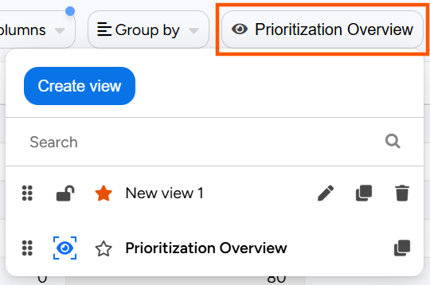
- Public views are denoted by the blue eye shaped icon 
These views cannot be edited in any way as they are administratively defined.
Always clone a public view using the copy icon , and then click into the newly created view to start working into it.
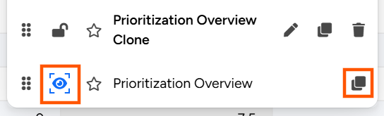

How to Update Project Attributes
Project attributes can be updated directly from the Project Management grid, both on an individual-level and in bulk.

Editing Attributes for a Single Project
- Hover over the cell. An edit icon will appear to the right of the cell.
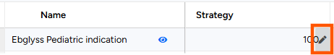
- Click the edit icon, choose the new value and click the green check mark icon. Alternatively, press Enter on your keyboard.
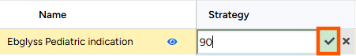

Editing Attributes for Multiple Projects
- Select projects by checking boxes to the left of project names. Selected rows will be highlighted.
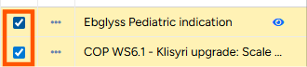
- To select a range of rows, select the row at the start of the range from the checkbox.
Press the Shift key on your keyboard and select the last row in the range. All rows will be highlighted.
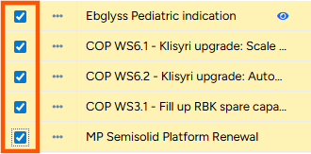
- Hover over any cell from selected rows. The edit icon will appear to the right of the cell.
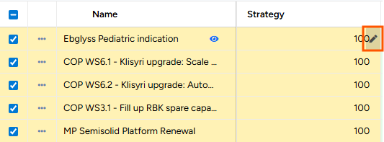
- Click the edit icon, choose the new value, and click the green check mark icon to update the value for all selected projects.


SINGLE PROJECT ALLOCATION GRID
The Single Project Allocation (SPA) grid is where allocations to a single project can be created or updated.
- Clicking on any project name in the grid will navigate to the Single Project Allocation grid by default. 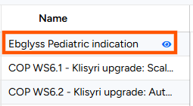
- Once a project has been created, and a valid date range has been entered, the Single Project Allocation grid becomes available.
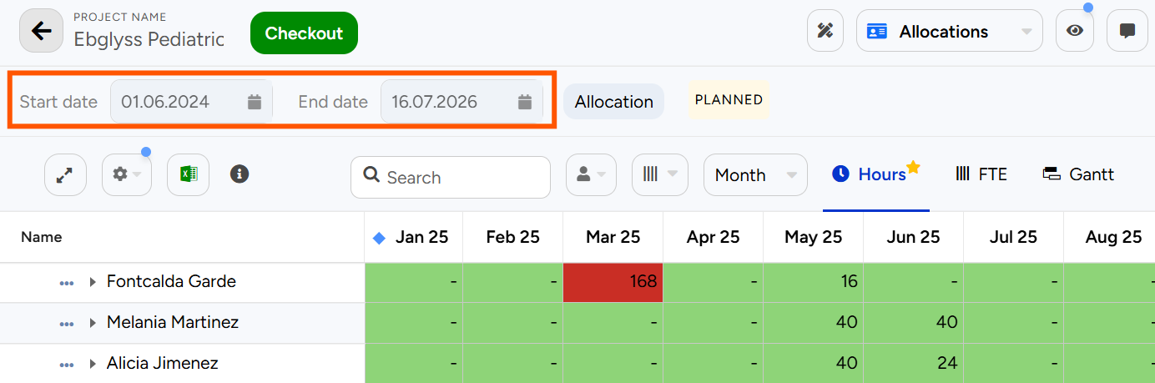

Grid Overview

      - The Project Name and Checkout button is located at the top of the grid.
To make any changes to a project, it must first be checked out.
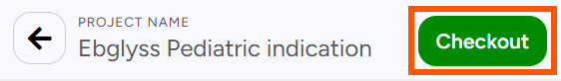
      - Basic options to update the grid are in the ribbon below the project start and end date.
- Expand the grid with one-click by clicking on
- Search for an assigned resource when the grid is grouped by Resource and for a task name when the grid is grouped by Task.
- Group by either Resource or Task.
- Insert Columns to view project, resource, or assignment attributes.
- Update Time Granularity by which allocations are displayed. Month is the recommended granularity.
- Choose the Capacity unit in which allocations are entered/displayed.
Hours is the recommended unit for capacity planning.

      - Advanced grid options can be found in the Options menu in the ribbon below the project timeframe.
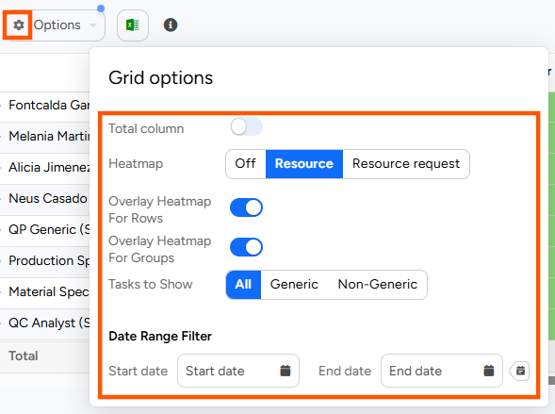
- Enabling the Total Column will display a column with total Hours.
When viewing the grid in FTE, it will display the average.
- A Resource Heatmap will display colours based on overall allocation% of a resource.
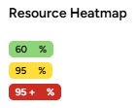
- Enabling Overlay Heatmap for Rows will apply the selected heatmap on individual grid rows.
- Enabling Overlay Heatmap for Groups will apply the selected heatmap on groupings.
- Tasks to Show will filter tasks and hide the task type that is not selected – generic or non-generic.
- The Date Range Filter will filter the grid for a specific timeframe without amending project timeframe.

How to Assign Resources to Projects
- Click Checkout next to the Project Name at the top to make any edits to the project.

- Expand the grid by clicking on the button with 2 arrows above the Name column in the grid.
- To add a single resource, click on a blue cell reading Type a new resource to start typing the name of the resource or select a resource from the dropdown.
Type-ahead functionality narrows down the available resources to simplify resource loading.
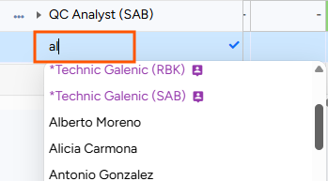
- To add multiple resources to one or multiple tasks, click on Add assignment to reveal the New Assignment dialog. Choose resources to the left and tasks to the right and click Add.
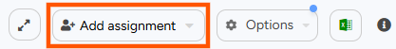
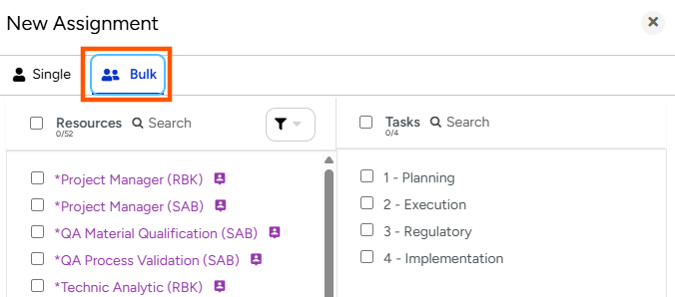
- To create a new task, scroll down to the end of the Task list to reveal a green row with the option to Type a new Task. Enter the name of the new task and hit enter or click the checkmark to the right of the cell.
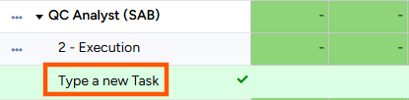
- Enter the allocation in Hours on a monthly level. Values can be copy-pasted or clicked and dragged.
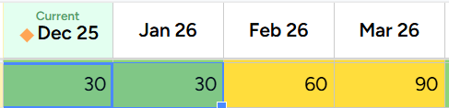
- To increase the allocated time for a named resource that has already been allocated to a project, enter the new total requested allocation directly in the grid.
- To save changes, click Save and Check In or Release them to revert to the previous state.
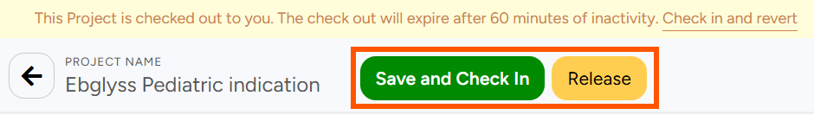

Replacing a Resource
There are two cases when a resource needs to be replaced in a project –
- A Demand Planning or Placeholder resource needs to be replaced with a named individual e.g., *Project Manager (RBK) needs to be replaced with Sönnke Grossmann.
- A named resource needs to be replaced with another member of the resource pool e.g., Sönnke Grossmann needs to be replaced with Antonio Gonzalez on a given project.
To replace a resource, click on the ellipses next to the resource name to access the Resource Replace screen.
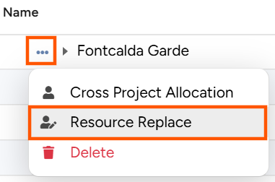

Resource Replace Screen
- The top of half of the screen displays the current allocation in a grid with the option to update the time granularity (Month/Quarter/Year/Week/Day) and capacity unit (FTE/Hours).
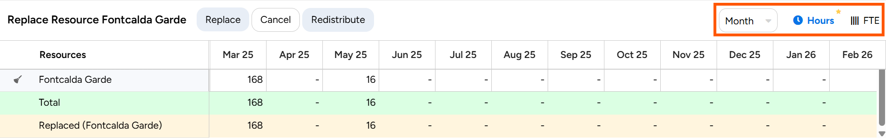
- The bottom half displays all resources in the resource pool in a Net Availability grid to manually query and find the best fit resource by applying filters, inserting columns, or applying a simple red/green heatmap from the Options menu.
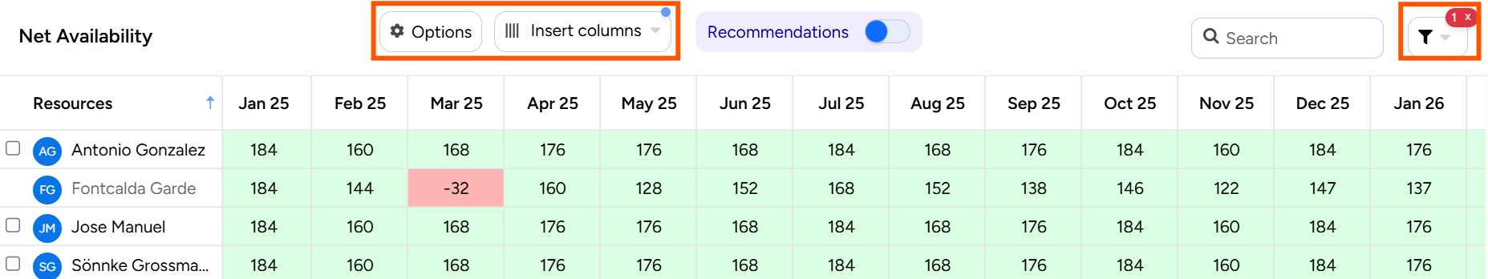

Fully or Partially Replacing a Resource
- Select replacement resource(s) from the bottom of the grid and they will automatically appear in the allocation grid above.
- To fully replace a resource, click Redistribute to copy the complete allocation from the original resource to the replacement resource(s). If multiple resources are selected, the original allocation will be equally redistributed among them.
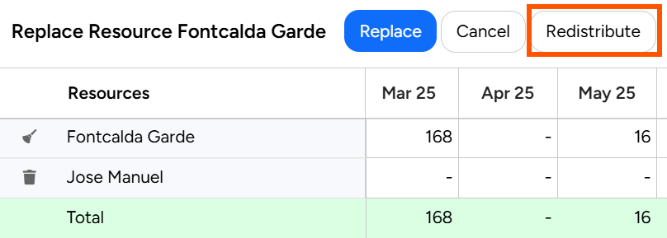
  - To partially replace the resource, update allocations directly in the grid ensuring that the Total row displays as green.
  - Click Replace at the top of the screen to complete the step.
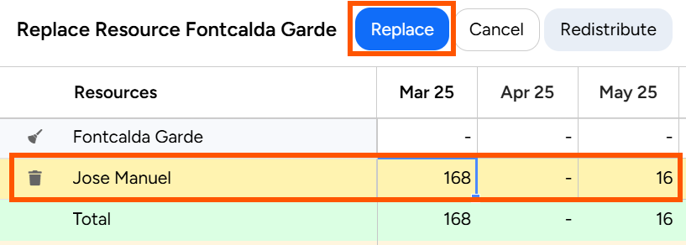

Advanced Assignment Options
Click on the ellipses next to the assignment name to access Assignment Options.
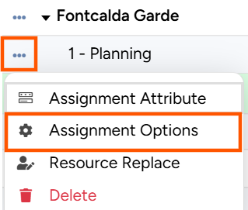

Cloning an Assignment
- To Clone an assignment,
  - Enter the Task name,
  - Add a New assignment start date,
  - If changing the resource, toggle on the option and select the new resource’s name,
  - Click the green Apply button to save changes.
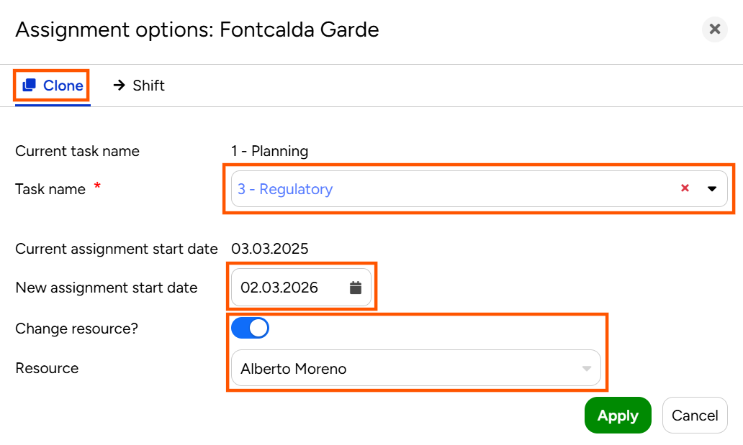

Shifting an Assignment
- To Shift an assignment
  - Click on Shift,
  - Enter a New Assignment Start Date,
  - Click the green Apply button to save changes.
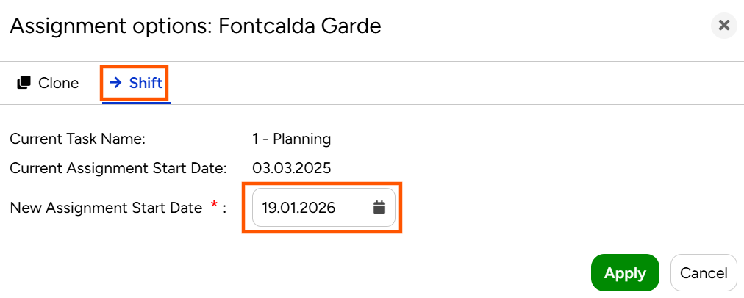

Bulk Project Allocation Flatgrid
The Bulk Project Allocation Flatgrid (BPA Flatgrid) is where allocations to multiple projects can be manipulated from the same screen. To access the BPA Flatgrid, click on the Bulk Project Allocation Flatgrid tile.
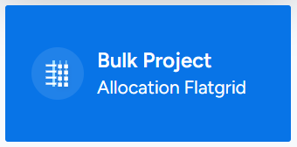

Grid Overview
    - Located at the top-left, is the Grid timeframe, which can be easily amended by the date-picker.
Additionally, there is a quick-select menu revealed by clicking 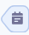 next to the End date with popular timeframes to choose from.
    - Towards the top-centre, is the Resource and Project menu, with 3 modes for entering data –
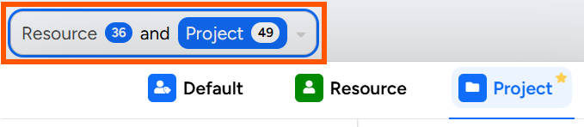
        - Project – Recommended mode for Project Managers.
Only projects can be selected. Only projects that coincide with the grid timeframe and with planned allocations will appear in the list.
        - Resource – Recommended mode for Resource Managers. Only resources can be selected. Only resources with planned allocation during the grid timeframe will appear in the list.
        - Default – Recommended when adding allocations to resources not already assigned to a project.
All projects and resources that the user has access to can be selected.

    - To the top-right, is the View Management dialog.
- Create a new view by clicking Create view  - Lock a view in its current state by clicking   - Select a Default view by clicking  - Edit a view by clicking  - Clone a view by clicking   - Delete a view altogether by clicking | 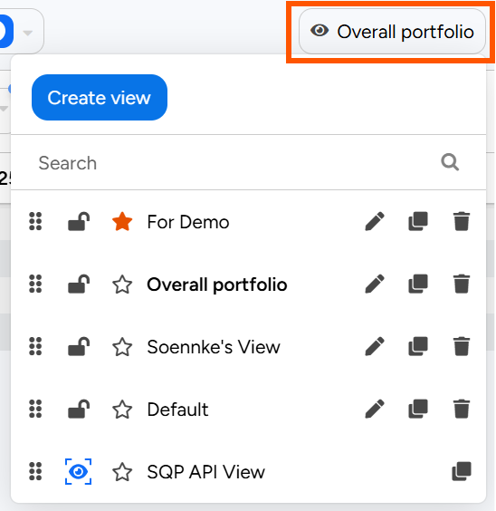
- Public views are denoted by the blue eye shaped icon 
These views cannot be edited in any way as they are administratively defined.
Always clone a public view using the copy icon , and then click into the newly created view to start working into it.
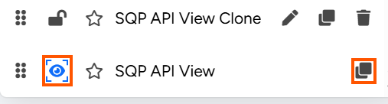
    - Basic options for customisation are in the ribbon above the grid.
- Expand the grid with one-click by clicking on
- Insert Columns to view project, resource, or assignment attributes in the grid.
- Group by any project, resource, or assignment attribute.
- Update Time Granularity by which allocations are displayed.
Month is the recommended granularity.
- Choose the Capacity unit in which allocations are entered/displayed.
Hours is the recommended unit.

    - Advanced options for customisation are in the Options menu in the ribbon above the grid.
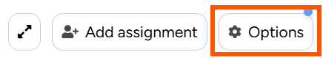
- Overlay Heatmap
- Resource Heatmap will display colours based on overall allocation% of a resource.

- Non-Zero Heatmap will display non-zero cells in blue
- Hide Task will hide the task column in cases where it is not relevant
- Show Total Row will insert a row with total allocations at every aggregation level.
- Show Total Demand Planning will display total allocations on Demand Planning or Generic Resources.
- Show Named Total will display total allocations on all Named Resources.
- Show Unallocated% will display the percentage of assignments to be redistributed from Generic Resources to Named Resources.
- Show Selection Calculations will display Average, Sum, Min, Max, Count for a grid selection
- Tasks to Show can filter the grid by task type – Generic (Project-level) or Non-Generic (Custom tasks)
- Weekly Display Format will display weeks in the chosen format – Week number, Start date, End date

    - Every column has a filter icon that allows to filter across resources, projects, and other inserted columns
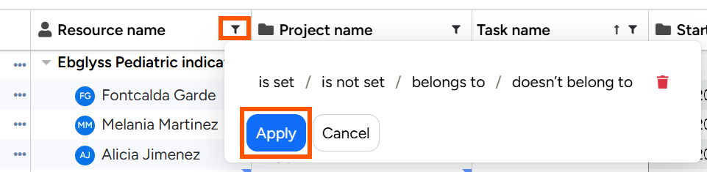
    - A blue triangle in cells containing project and resource names opens a view only modal window for all project/resource attributes

    - Hovering over a Project or Resource name reveals a hyperlink.
Clicking on the link will redirect to the dedicated Project or Resource page in a new browser tab
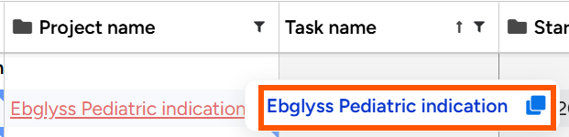

How to Create a Multi-Project View
- From the View management window, clone the Project-Centric View view and click on the newly cloned view.
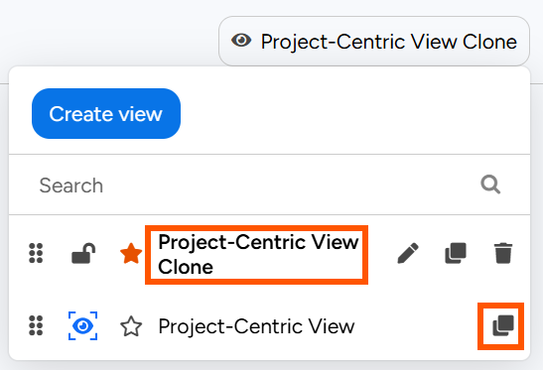
- Update the grid timeframe as needed, optionally using the quick select menu to choose common timeframes.
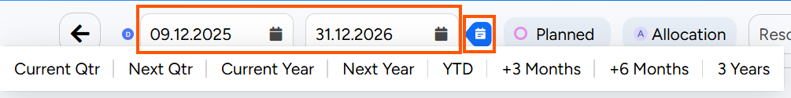
- Open the Resource and Project menu by clicking on it. Locate project(s) by typing in the name in the search field next to Projects or apply a project filter to see multiple projects meeting the same criteria.
NOTE: Only projects with planned allocations during the timeframe selected will appear in the Projects list.
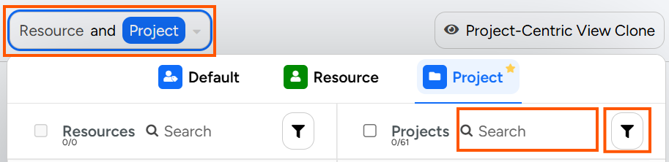
- Select projects from the list. Assigned resources will be auto selected to the left.
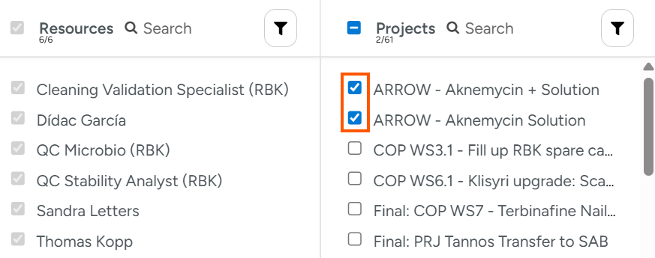
- Expand the grid to view a dedicated row for each Resource-Project-Task combination.
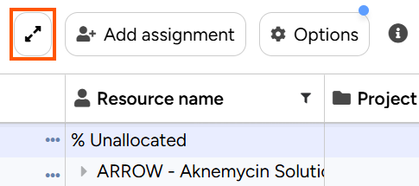
- Existing allocations will appear in Hours on a monthly level with a Resource heatmap applied, first grouped by Project and then Resource.
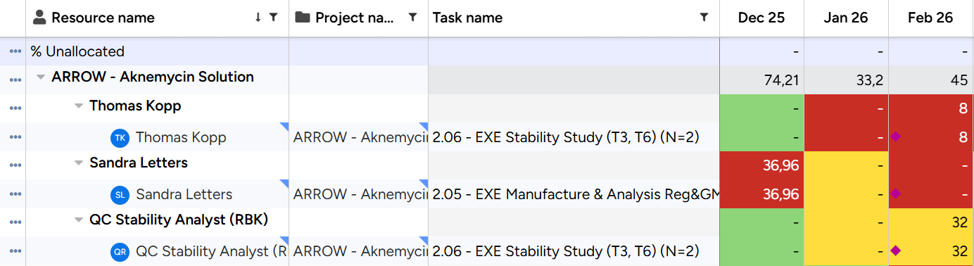

Actions in the BPA Flatgrid
Project Managers can perform various actions in the BPA Flatgrid. Each of these actions is outlined below.

Updating existing assignments
- The BPA Flatgrid will display a dedicated row for each Resource-Project-Task combination. To update an assignment, click into a cell and update the value.
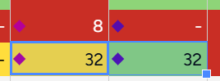
- Click Save at the top-left of the grid to save changes.
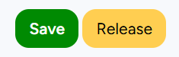

Adding new assignments
- Click on Add assignment.
Select a Project, a Resource, and a Task and click Add new assignment.
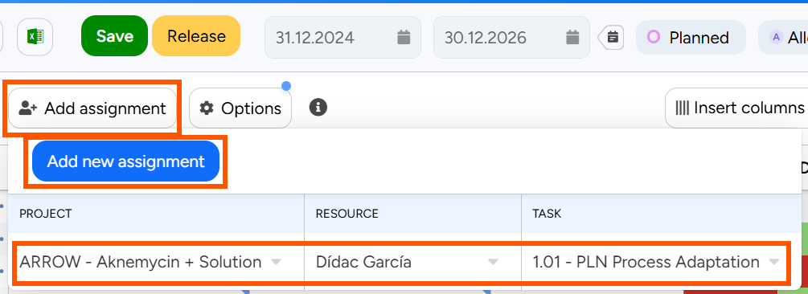
- When in the Project mode of the BPA Flatgrid, it is possible to select a resource not already assigned to a project, select the checkbox Allow new Resources from the Resource dropdown.
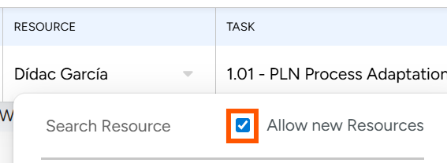
- To create a new task not already present in the project, enter the name of the task and click Add new Task
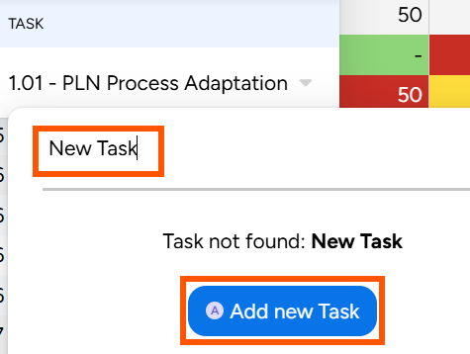
- A new row with the Project-Resource-Task combination will appear in the grid.
To add assignments, click on a cell and enter the assignment value.
- Click Save at the top of the grid to save changes.


Replacing a Resource (Resource Replace Advanced)
There are two cases when a resource needs to be replaced in a project –
- A Demand Planning or Placeholder resource needs to be replaced with a named individual e.g., *Project Manager (RBK) needs to be replaced with Sönnke Grossmann.
- A named resource needs to be replaced with another member of the resource pool e.g., Sönnke Grossmann needs to be replaced with Antonio Gonzalez on a given project.
To replace a resource assigned to a project, click on the ellipsis icon next to a resource name and choose Resource replace advanced.
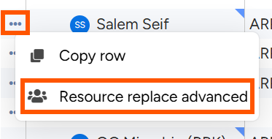

Resource Replace Advanced Screen
- The top of half of the screen displays the current allocation in a grid with the option to update the time granularity (Month/Quarter/Year/Week/Day) and capacity unit (FTE/Hours).
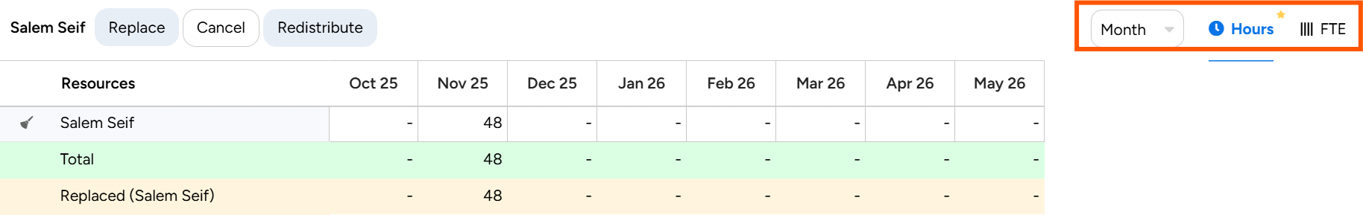
- The bottom half displays all resources in the resource pool in a Net Availability grid to manually query and find the best fit resource by applying filters, inserting columns, or applying a simple red/green heatmap from the Options menu.
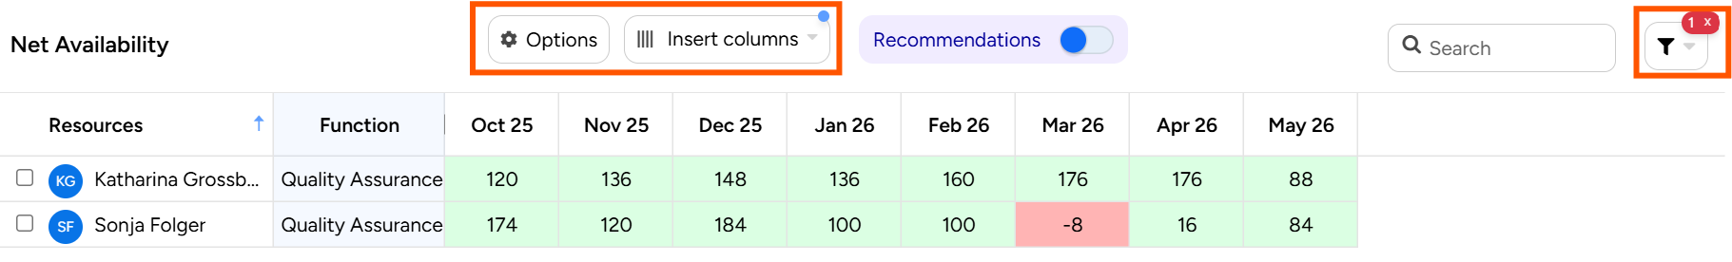

Fully or Partially Replace a Resource
- Select replacement resource(s) from the bottom of the grid and they will automatically appear in the allocation grid above.
- To fully replace a resource, click Redistribute to copy the complete allocation from the original resource to the replacement resource(s).
If multiple resources are selected, the original allocation will be equally redistributed among them.
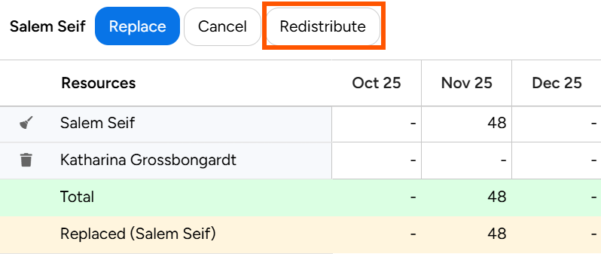
  - To partially replace the resource, update allocations directly in the grid ensuring that the Total row displays as green.
  - Click Replace at the top of the screen to complete the step.
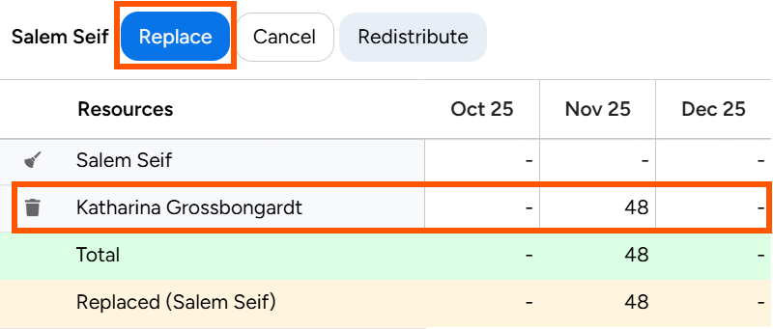
- Click Save at the top of the BPA Flatgrid to save changes.


